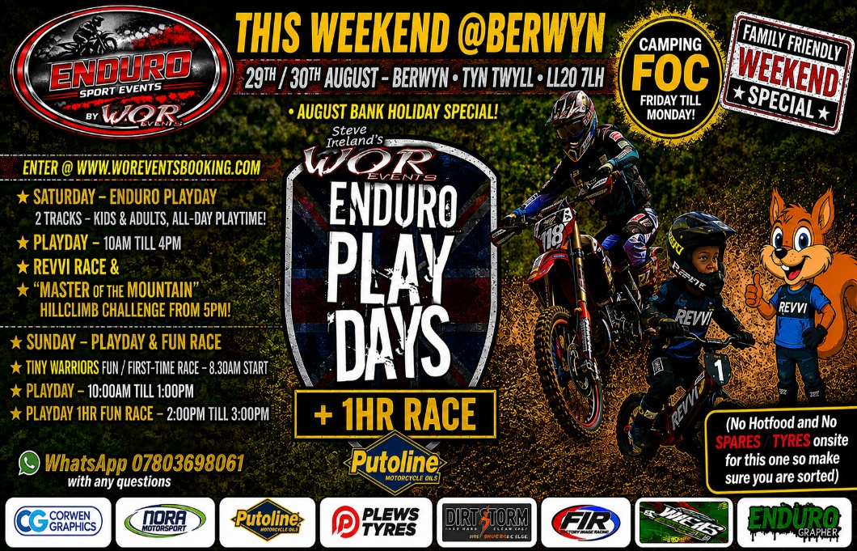
FINAL INSTRUCTIONS – ENDURO SPORT EVENTS - PLAYDAY SAT & SUN with 1hr Intro / Fun Races both days
@BERWYN LESUIRE / TYN TWYLL
POSTCODE LL20 7LH
CAMPING ONSITE – FOC – FROM FRIDAY 28th AUGUST @5PM
All riders must vacate by 11AM MONDAY 31st AUGUST
MAKE SURE RUBBISH AND LITTER AROUND YOUR CAMP IS COLLECTED WHEN LEAVING SITE!! – Any litter left will have a massive impact!!
PAYMENT OF ENTRIES & CATERING BY CASH PLEASE AS NO INTERNET OR SIGNAL AT VENUE
SATURDAY – ENDURO PLAYDAY 10AM TILL 4PM - SIGN ON 8AM TILL 10AM
PLAYDAY RIDERS FUN 1HR RACE 2.45PM TILL 3.35PM
REVVI / KIDDIES 20-minute fun race – 5PM – Sign on 4.15pm (foc)
MASTER OF THE MOUNTAIN FUN HILLCLIMB 6PM TILL 8PM.
ENTER ONSITE FROM 5PM TILL 5.30PM (foc although donation for Air amb will be asked for)
……………………………………………………………………………………………
SUNDAY – ENDURO PLAYDAY 10AM TILL 1PM – SIGN ON- 8AM TILL 10AM
PLAYDAY RIDERS FUN 1HR RACE 2PM TILL 3PM
………………………………………………………………………………………….
PLEASE FOLLOW AND ADHERE TO ALL OF THE FOLLOWING POINTS:
FAILURE TO COMPLY WITH ANY OF THE FOLLOWING RULES AND REGS WILL RESULT IN EXCLUSION
FROM THE VENUE AND EVENT.
- STAY ON THE MARKED COURSE PLEASE
- PLEASE ARRIVE EARLY FOR SIGN ON!!
3.CAMPING IS ALLOWED FRI / SAT/ SUN NIGHT ONLY.
4. ALL PARTICIPANTS MUST RESPECT AND OBEY THE ORGANISERS AND STAFF WHILST ONSITE TO KEEP A SMOOTH AND TROUBLE-FREE EVENT.
5. ALL RIDERS TO NEVER TRAVEL AGAINST TRAFFIC ON THE COURSE / IF BROKEN DOWN OR GOT A PROBLEM / WAIT – ASSISTANCE WILL ARRIVE !!
6. NO SPEED IN THE PADDOCK- / NO RIDING ANYWHERE WITHOUT A HELMET / NO KIDS OR PARENTS ON ELECTRIC BIKES ANYWHERE IN PADDOCK/ NO PASSENGERS ON BIKES - IF YOU DO YOU WILL BE ASKED TO STOP IMMEDIATELY Competitors MIN 2MPH TO TRACK -
7. ALL RIDERS MUST BE SIGNED ON – NO EXCEPTIONS
8. THERE WILL BE MEMBERS OF STAFF VISITING THE SIGN ON QUEUE TO OFFER NORA DAY LICENCE ASSISTANCE
9. ALL RIDERS MUST ARRIVE AT LEAST 90 MINS EARLY FOR THEIR EVENT.
10. STRICTLY NO CAMPFIRES OR / BBQS / NO FIREWORKS.- NO SMOKING AROUND THE VENUE – ONLY AT YOUR OWN VEHICLE – DISPOSE OF IN AN ASHTRAY OR SECURE PLACE- THE GROUND IS DRY AND FIRERISK IS MASSIVE … THESE ARE NOT ONLY OUR RULES BUT ALSO THE GOVERNMENT AND LANDOWNERS !!!! – ANY NON COMPLIANCE AND YOU WILL BE LEAVING THE VENUE / EVENT!!
12.ALL GENERATORS AND NOISE / MUSIC ETC TO STOP 11PM ON THE DOT.
13.IMPORTANT - ALL DOGS ON LEADS AND NOT IN PITS PLEASE – THE FARM MANAGERS ARE ADAMANT ABOUT DOGS ONSITE BEING FULLY ON LEADS AT ALL TIMES – FAILURE TO DO SO W NON-COMPLIANCE AND YOU WILL ASKED TO LEAVE!!!
14.TOILETS AND WATER ONSITE – STAND IN CATERER WILL HAVE BACON / BURGERS / HOT COLD DRINKS / CAKES / SWEETS ETC – CASH ONLY!! – NO SPARES SHOP OR TYRES AT THIS EVENT!
15.EXCLUSION FOR ANY RIDER/ GUEST THAT DOES NOT FIT IN WITH ANY OF THE ABOVE RULES.
16. ALL RACERS ON SAT & SUNDAY TO HAVE RACE NUMBER ON FRONT OF BIKE AT LEAST.
BIKE – YOU PROVIDE THESE! - NO CLEAR NUMBER– NO SCORE AT LAP CONTROL – YOU HAVE BEEN WARNED!! –
NO HOME MADE NUMBERS – AND NO BLACK ON BLACK ..YES SOME PEOPLE DO!!!!!!!!!!!!!
ANY TYRES ARE ALLOWED FRONT AND REAR
ANY BIKE IS ALLOWED – MX OR ENDURO – TRAIL -TRIAL – ELECTRIC -
WHEN TWO ORANGE ARROWS FORM A GATE ON THE COURSE / YOU MUST PASS THROUGH THE MIDDLE OF THIS. FAILURE TO DO SO IS DISQUALIFICATION.
CROSSED ARROWS MEANS “ATTENTION / CARE “
KNOCKING DOWN TAPE AND ARROWS IN THE FLOWING FIELD SECTIONS WILL RESULT IN A YOU BEING REMOVED FROM THE CIRCUIT.YOU HAVE BEEN WARNED !!
ANY EXCESSIVELY NOISY MACHINES WILL BE REMOVED FROM THE COURSE 94-96db is Guide.
17. STRICTLY NO TEAR OFF’S. !!!!!!!!!!!!!!!
19. PLEASE TAKE ALL LITTER HOME WITH YOU – WE PLEAD THIS!! –
20. ZERO TOLLERANCE ON DRUGS AT ALL EVENTS – does not mix with the ethics of motorsport or the FAMILIES we have attending our events in ANY way..
THANKS FOR SUPPORTING THIS EVENT WEEKEND.
WE ALL ARE REALLY LOOKING FORWARD TO SEEING THE RIDERS AND RACERS AT THIS SUPERB VENUE AND EVENT.
FOR FULL WOR RULES VISIT : https://worevents.com/rules/
Abuse of the staff / venue or anything deemed unacceptable by Steve, and the team will result in exclusion and you being removed from the venue.
Contact / Whats App 07803698061 with any queries.

